**Milestone-1**

**Service Creation that Bright Ideas Consulting Offering :**

1.Management Consuting:

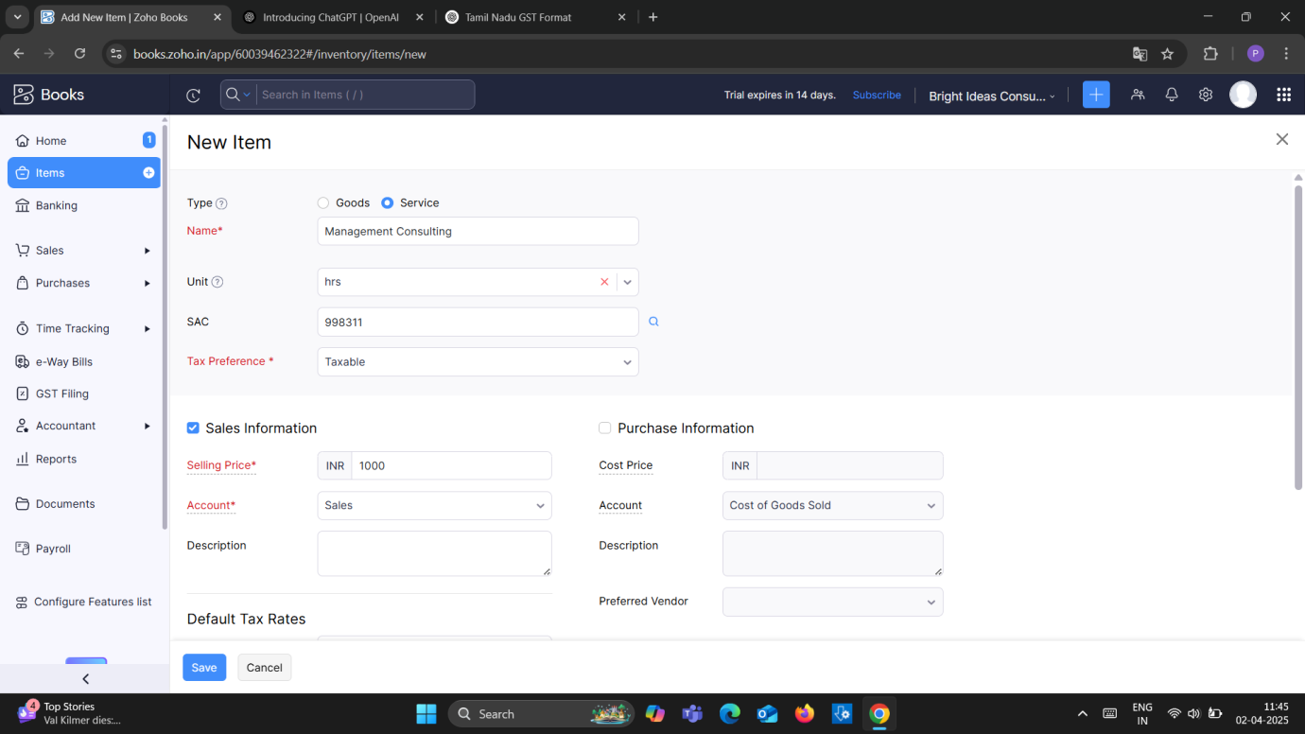

2. Financial Consuting:

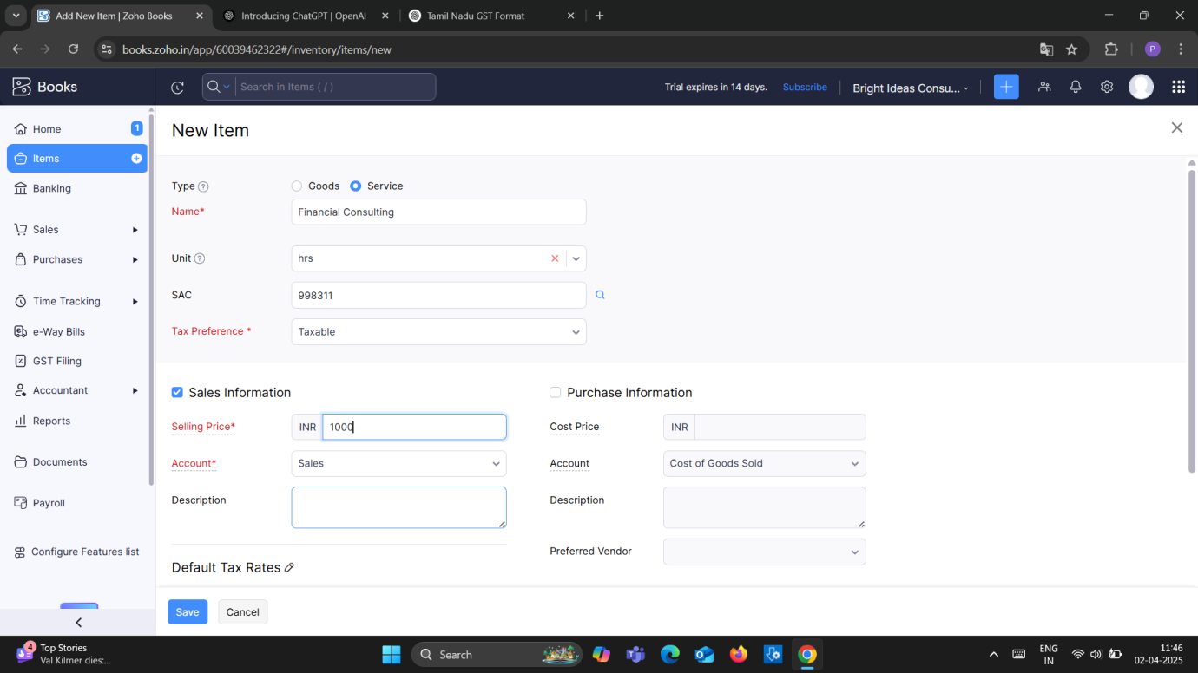

3.Human Resource (HR) Consuting:

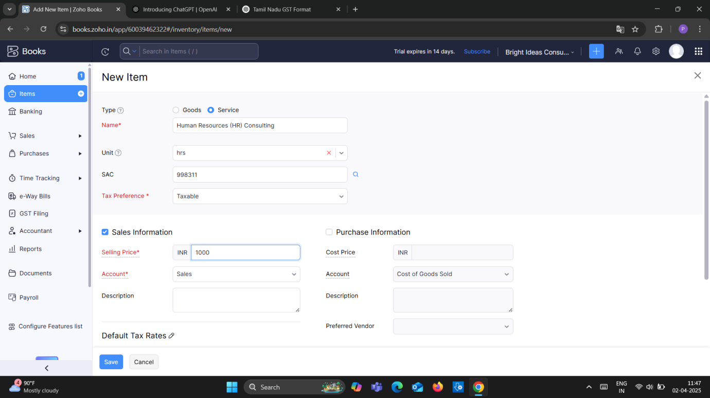

4.Legal Consulting:

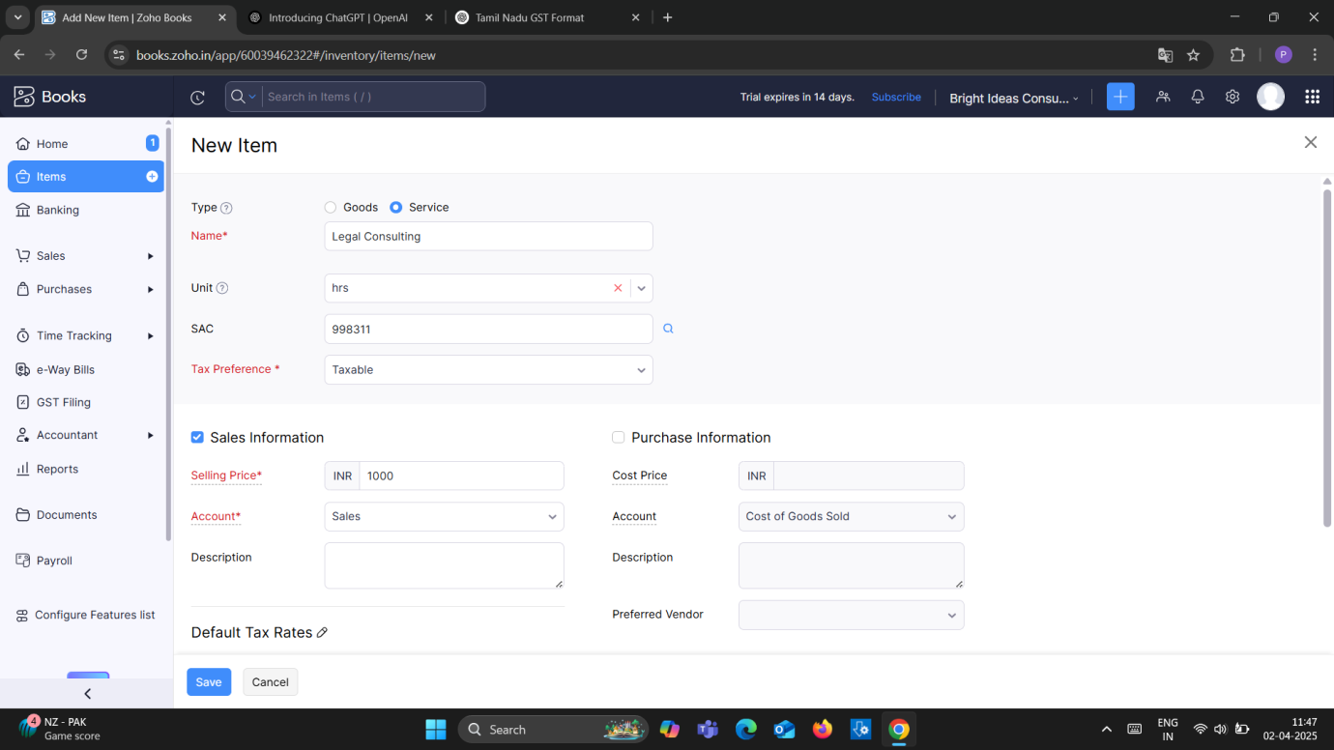

Note- Selling Price for all the above services is Rs.1000/- per consulting hours. Output GST @ 18% is applicable for all the above services.

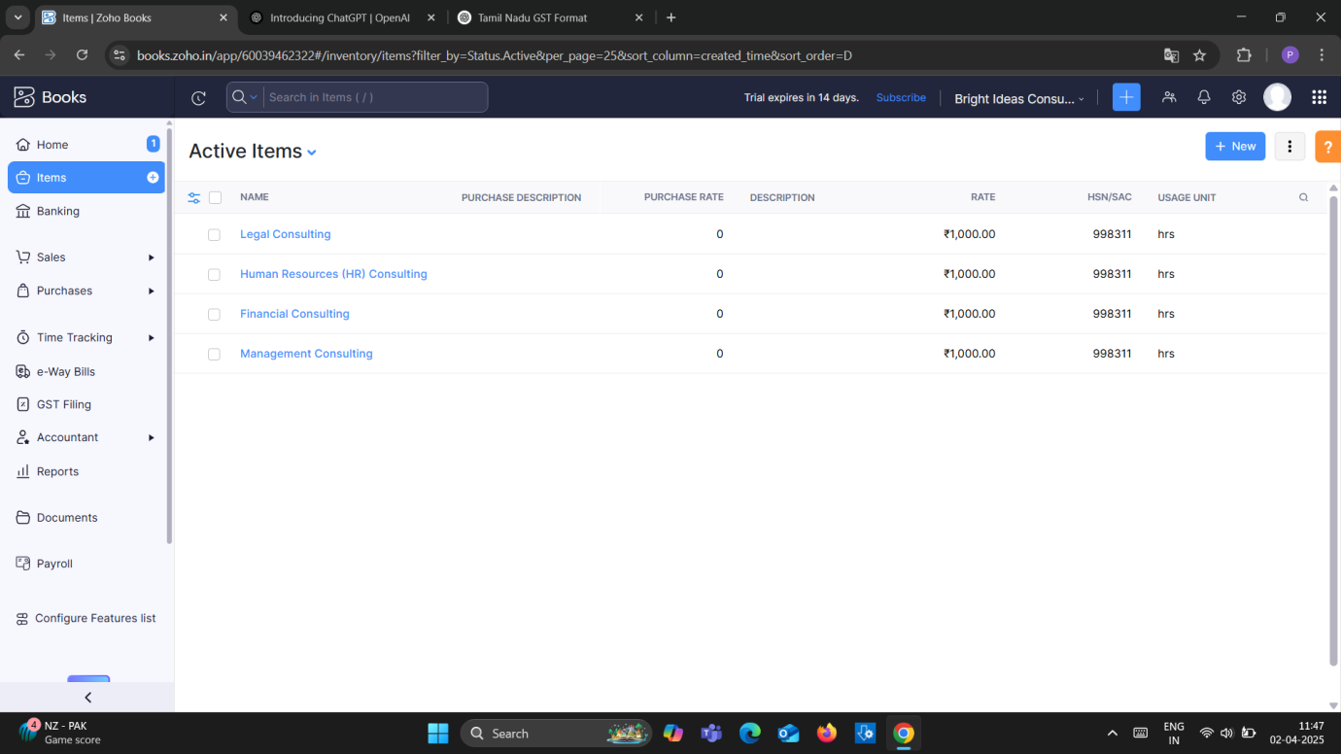

**Milestone-2**

**Creation of Vendors-**

1. **Randstad Technologies ( GST Registered )**

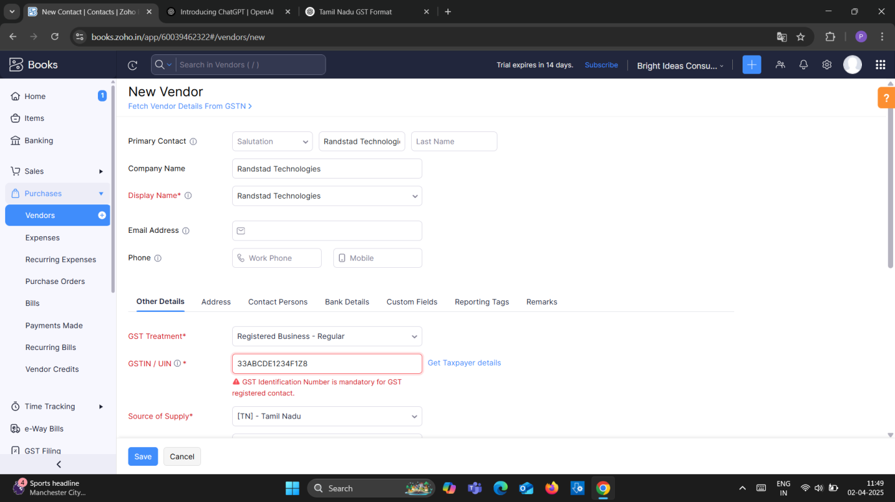

1. **Amazon Web Services ( GST Registered )**

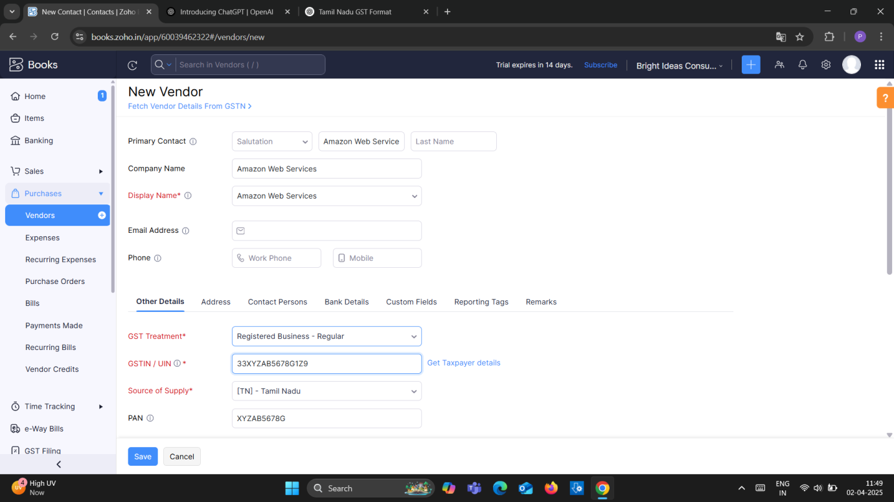

1. **Raj Kamal External Consulting (Non GST Registered)**

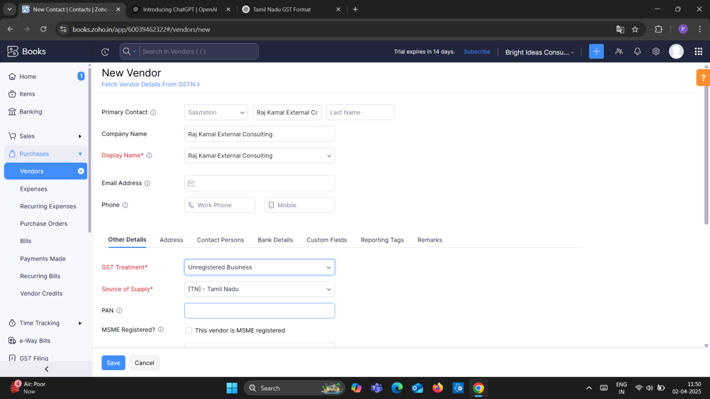

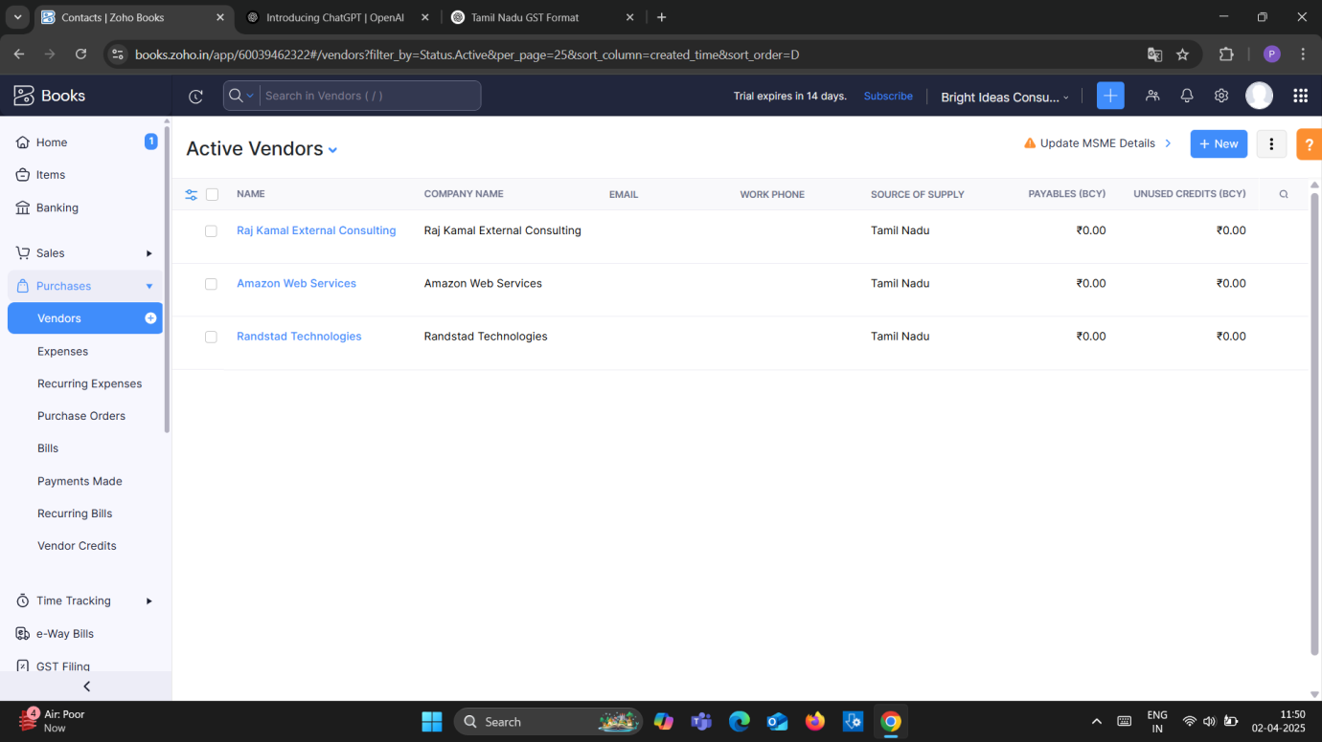

**Milestone-3**

**Activity-1**

1. **05/04/2023 Randstad Technologies**

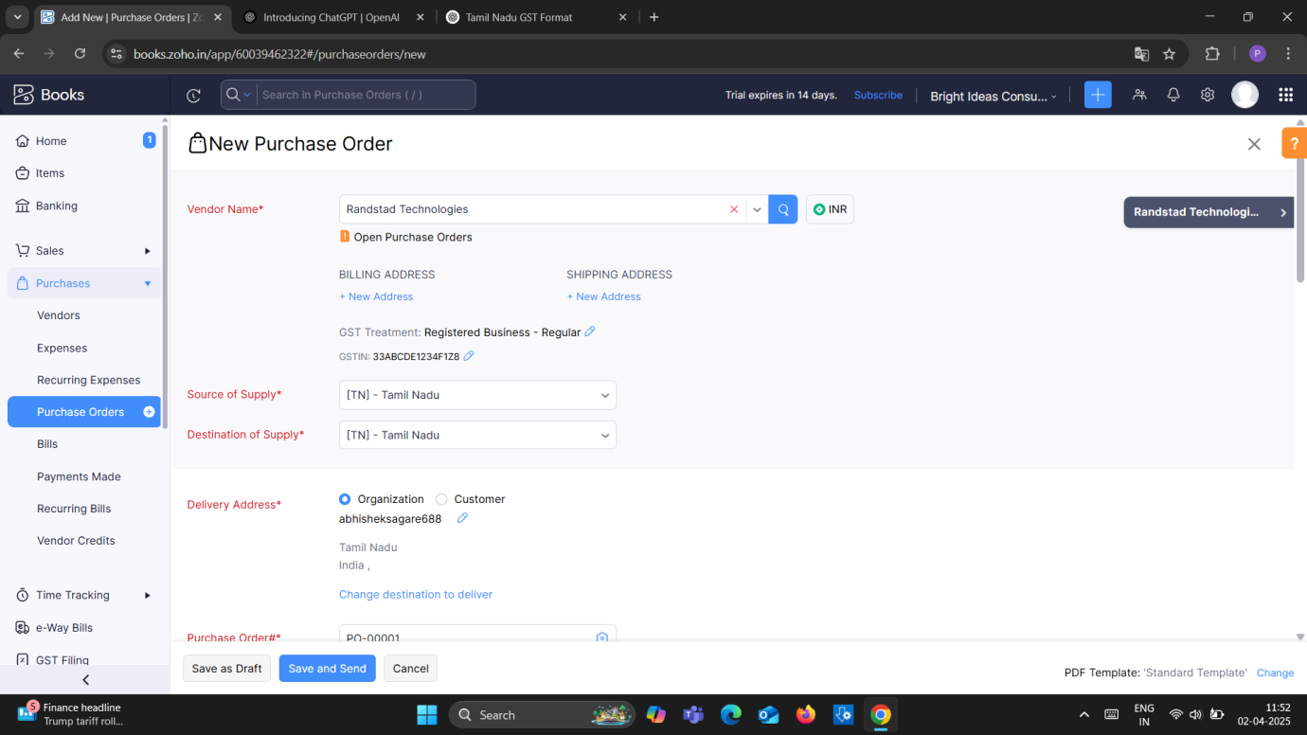

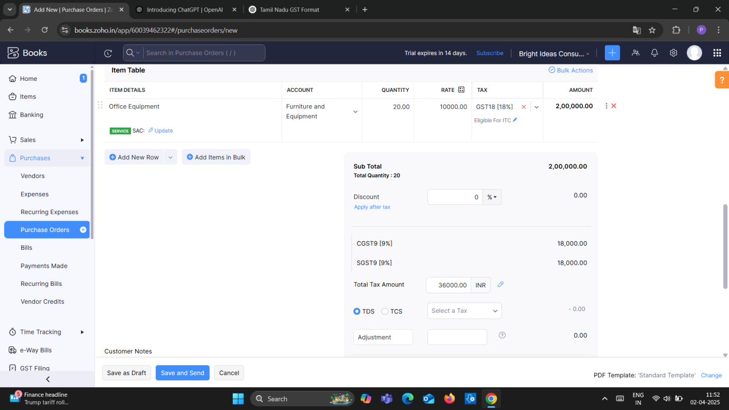

**Activity-2**

Purchase Order to Purchase Bills Conversion:

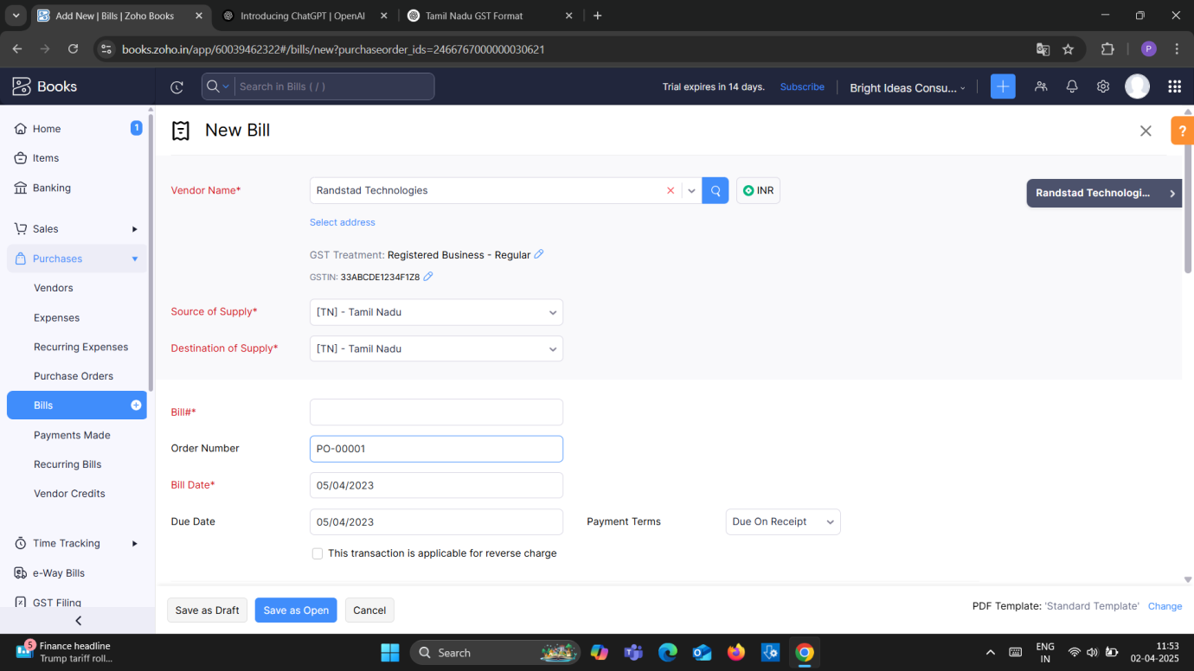

**Activity-3**

**Direct Vendor Purchases Bills Creation:**

1. Amazon Web Services

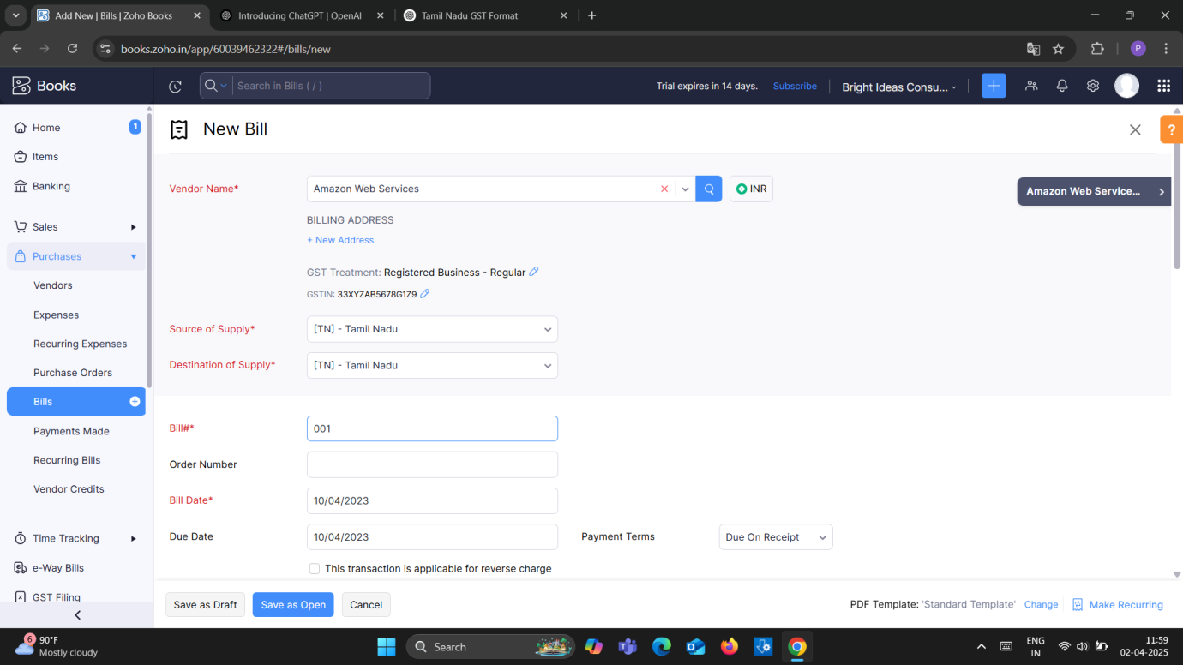

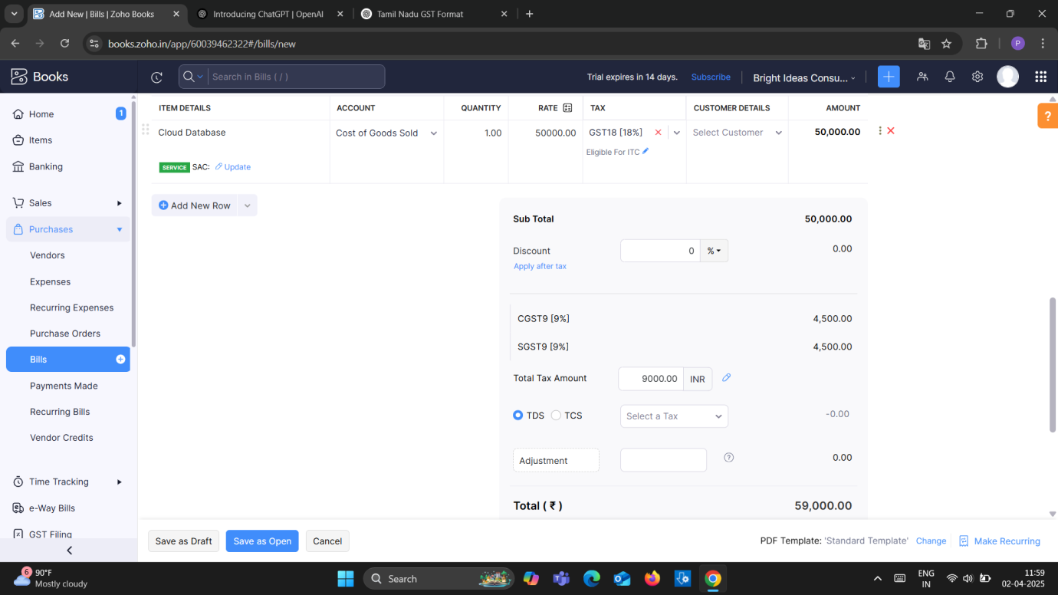

2.Raj Kamal External Consulting.

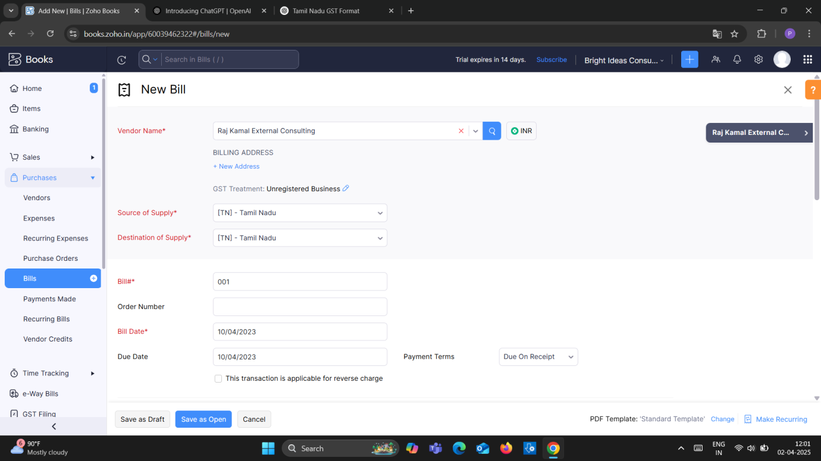

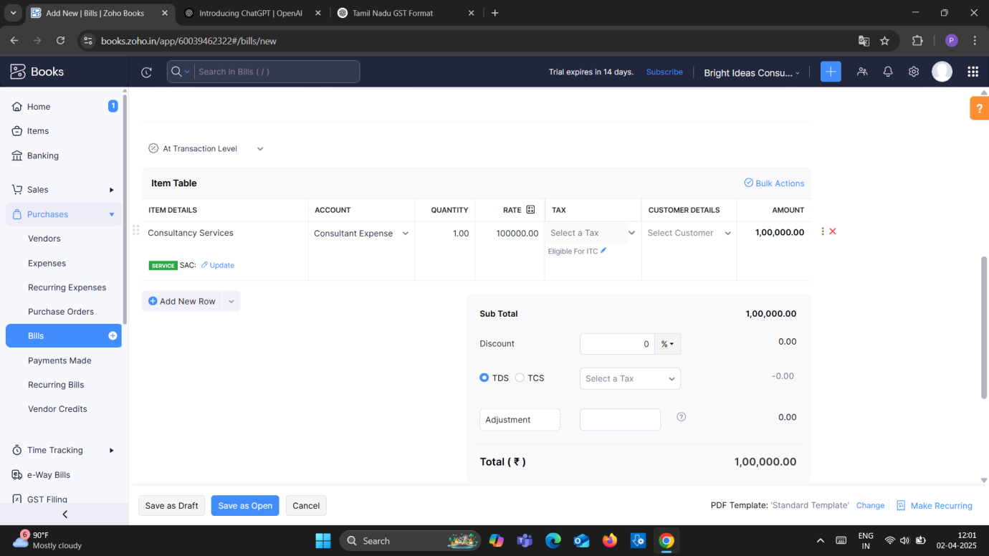

**Milestone-4**

**Customers Creation**

1. **Techwise Solutions Pvt Ltd (GST Registered):**

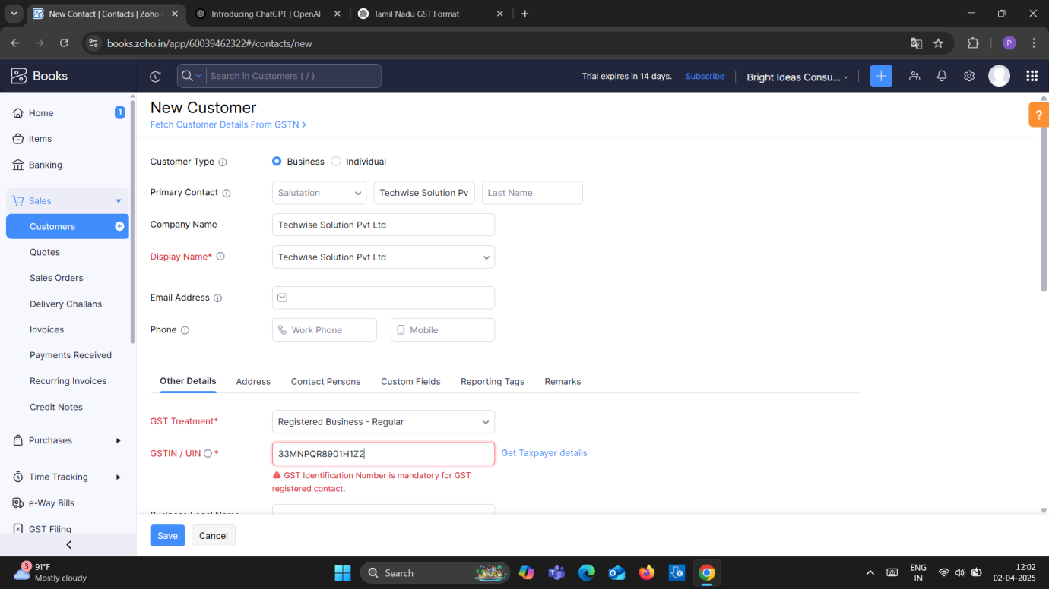

1. **DigitalEdge Technologies Pvt Ltd (GST Registered):**

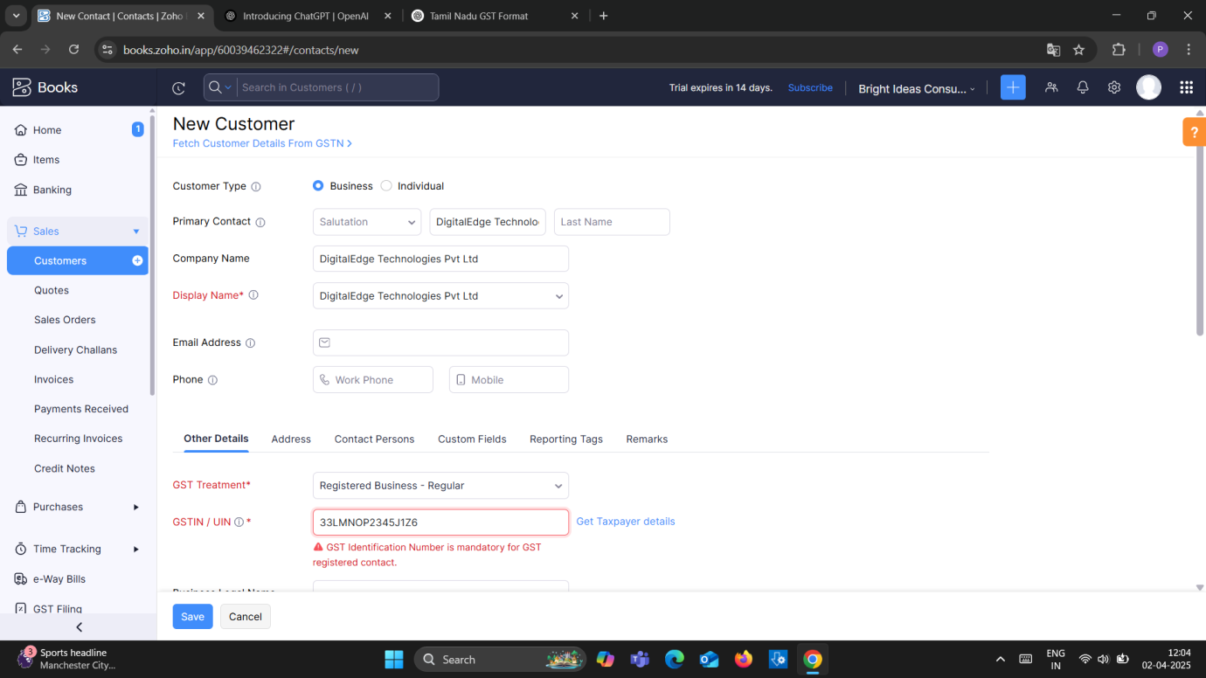

1. **SmartTech Innovations (Non- GST Registered)**

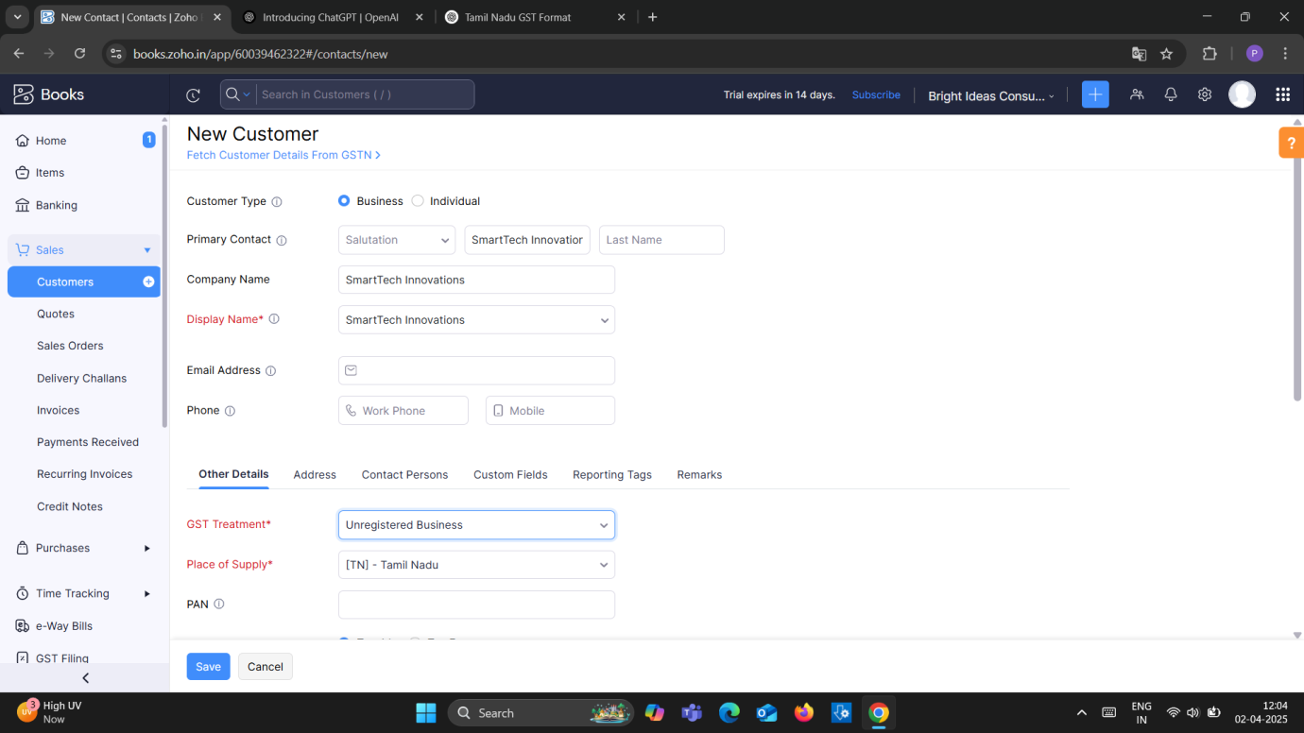

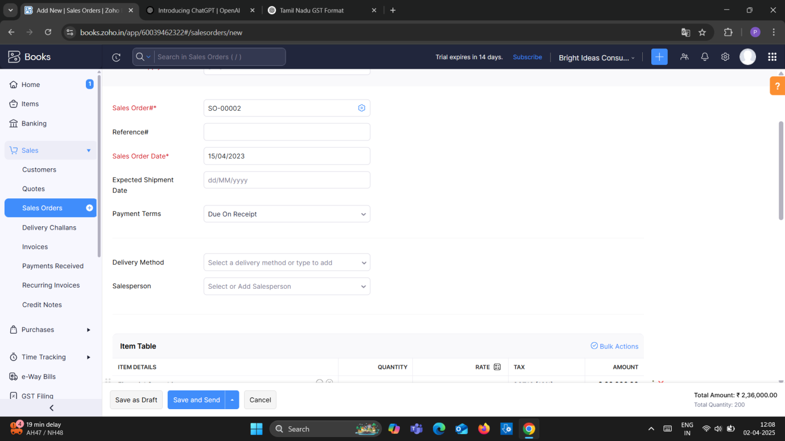

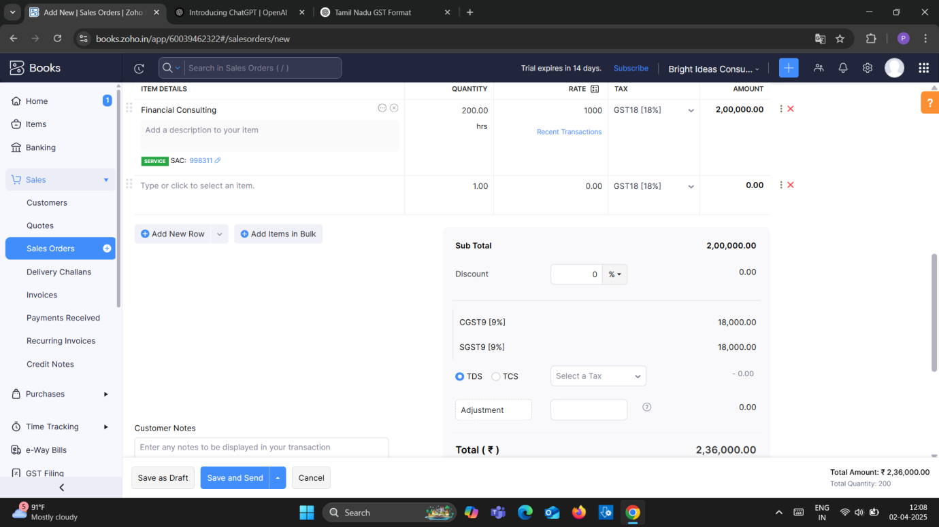

**Milestone-5**

**Sales Order Creation**

**Activity-1**

1. Techwise Solutions Pvt Ltd

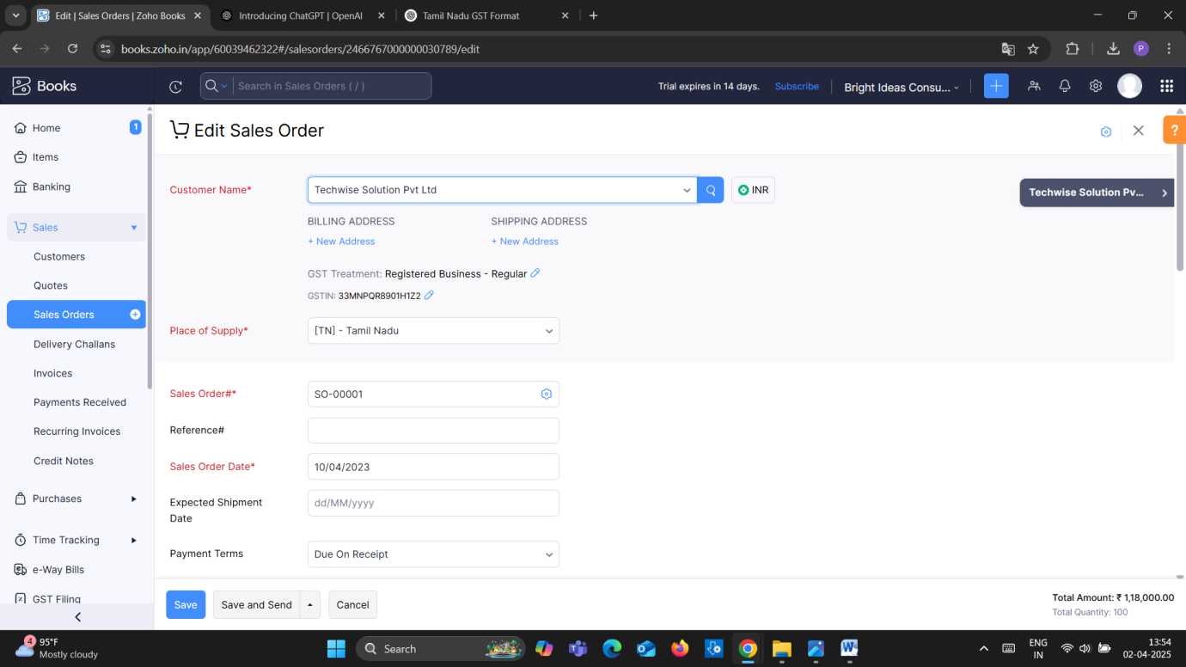

**Activity-2**

**Sales Order to Sale Invoice Conversion:-**

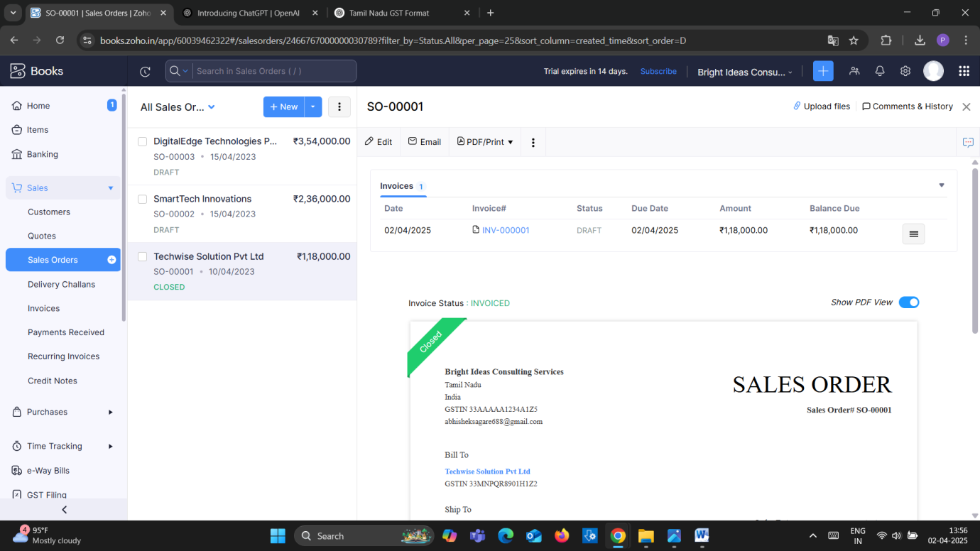

**Activity-3**

**Review of Techwise Solutions Pvt Ltd:**

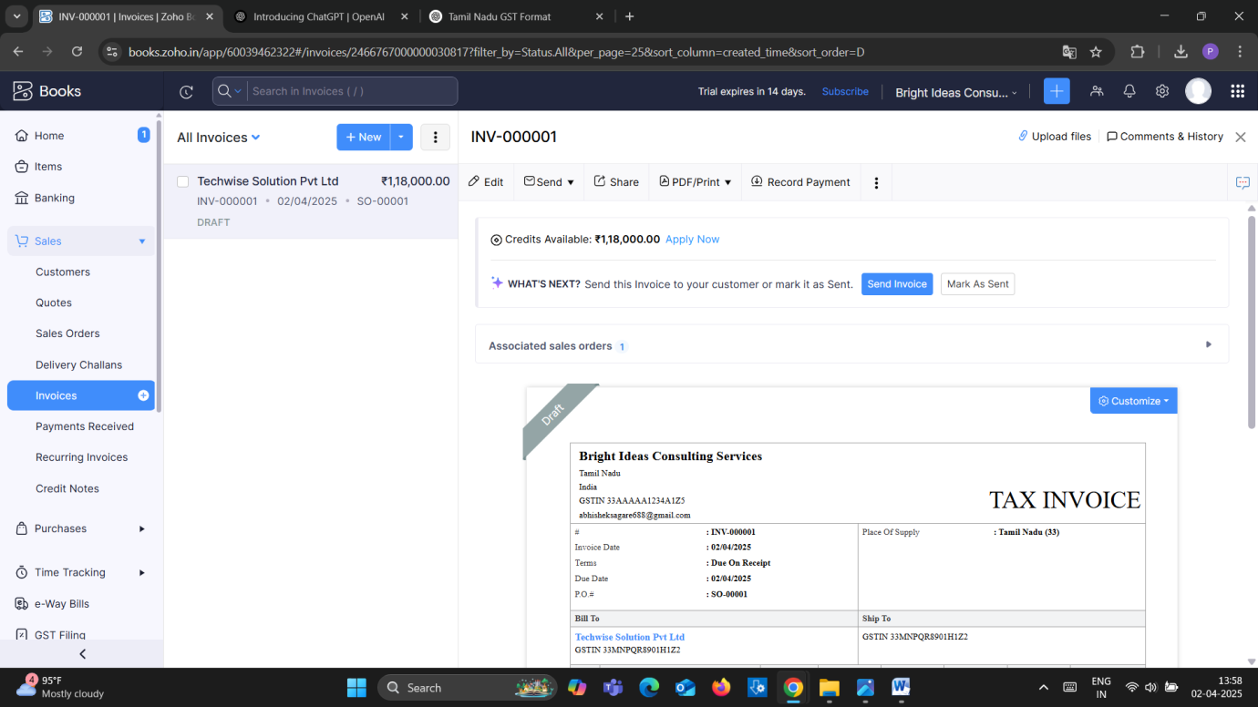

1. SmartTech Innovations

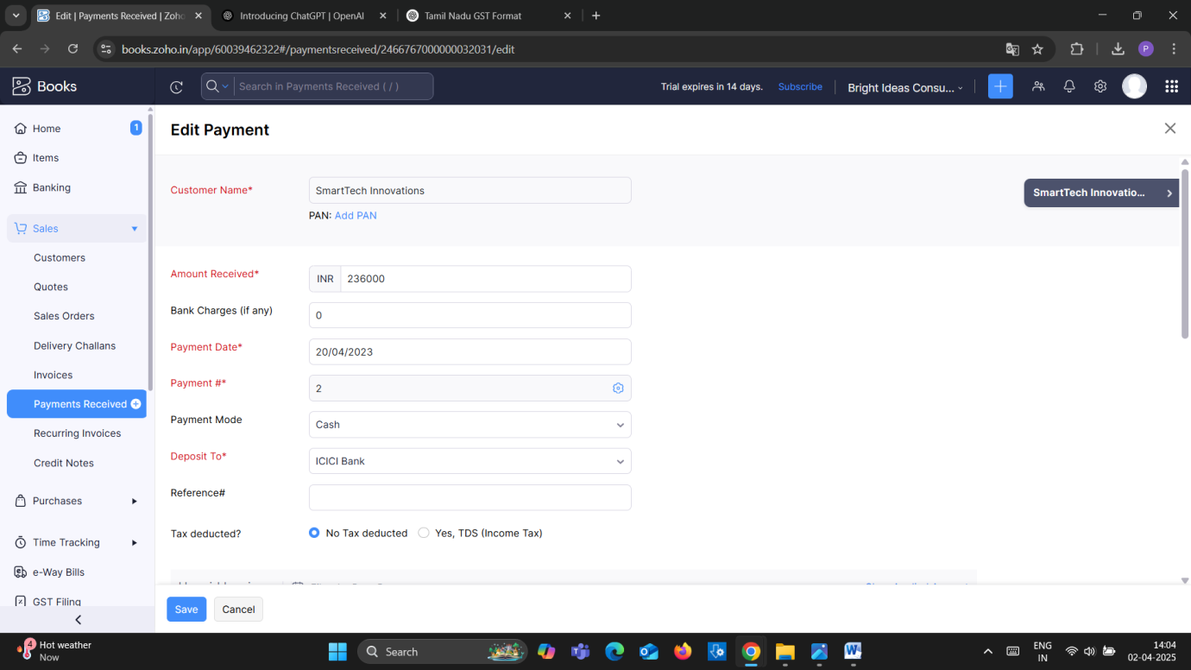

2.DigitalEdge Technologies Pvt Ltd

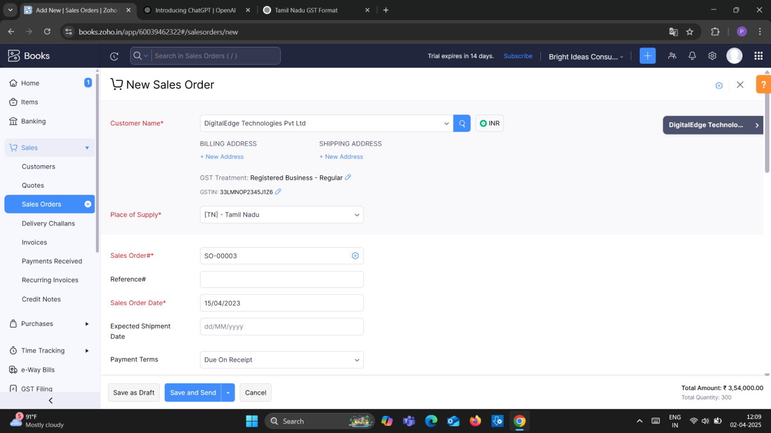

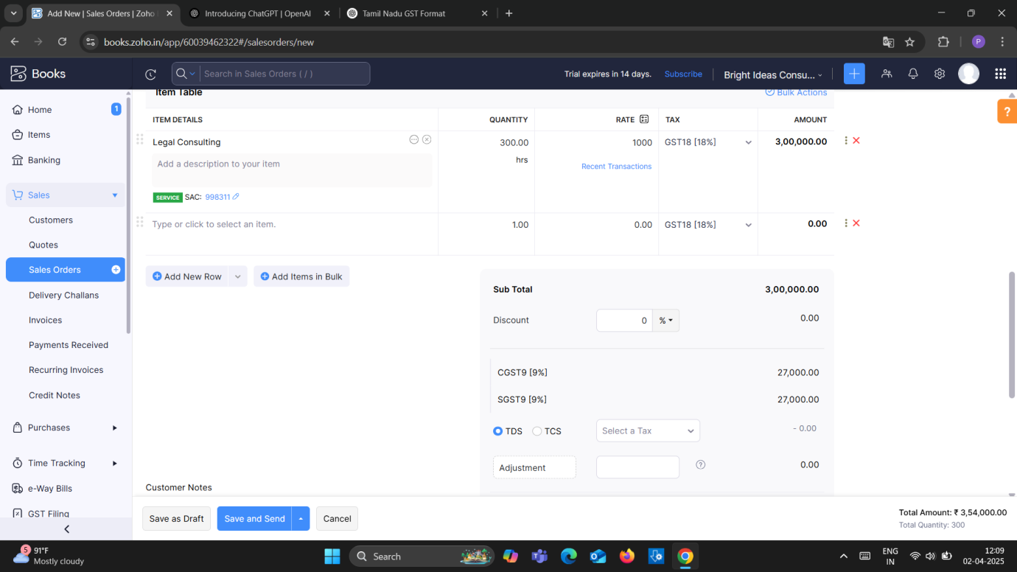

**Milestone-6**

**Adding Bank Account:-**

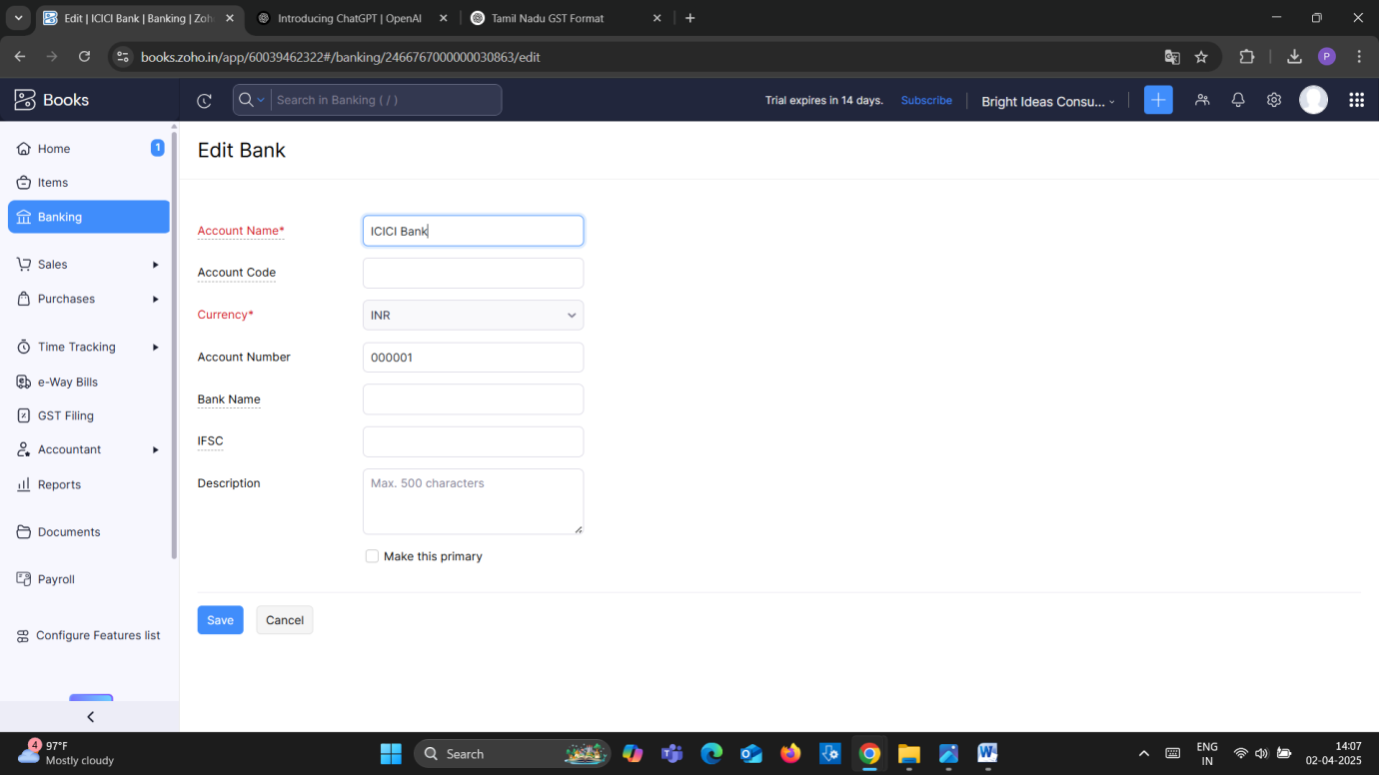

**Milestone-7**

**Journal Entries**

Employees Salaries of total Rs.1,00,000/- paid

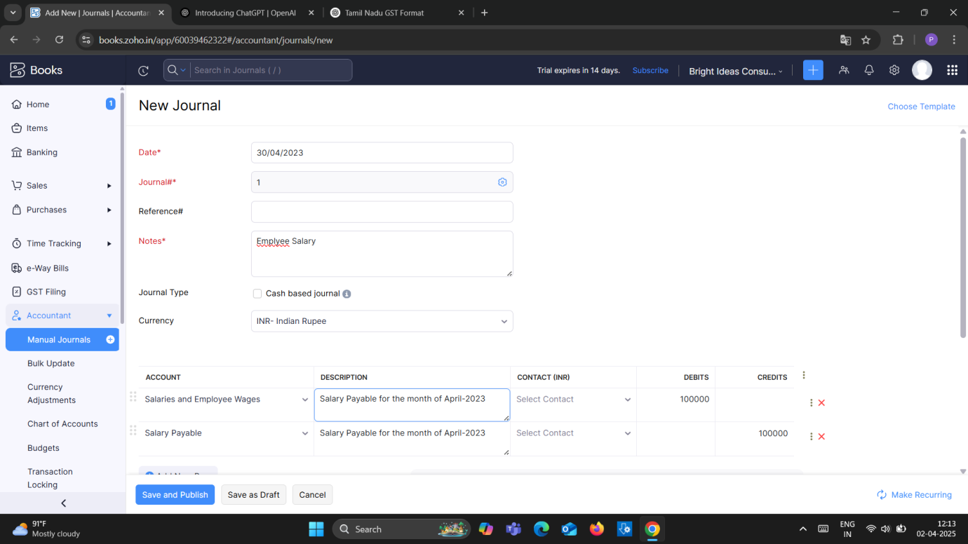

**Milestone 8**

1. Office Rent Rs. 1,00,000/-

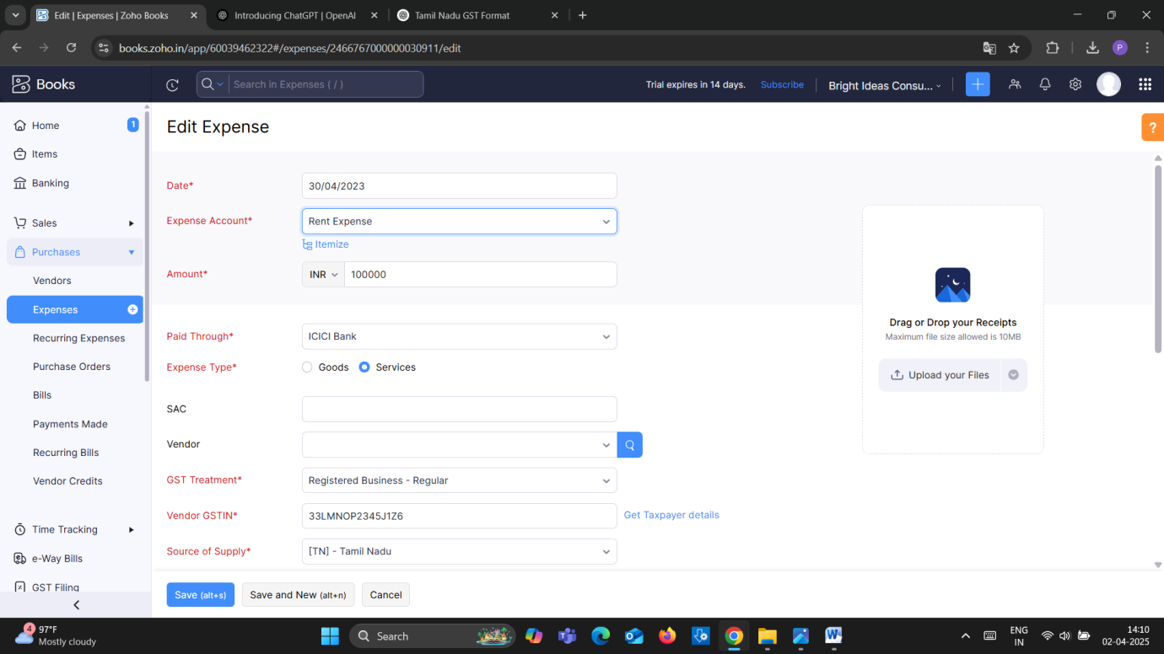

1. Other Miscellaneous Expenses Rs. 5,000/- paid in cash

